**Parts where we can add depenedencies**

-> Pom.xml

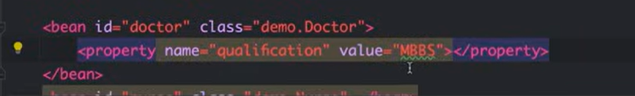

How to add values you to the paramters of doctor, when creating if you don’t want to get null,

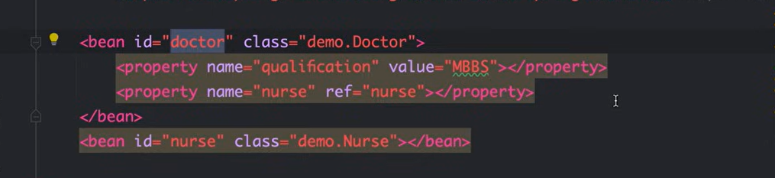

If you want to inject nurse into doctor, we can do this, by getteres and setters by having a paramter int the class of doctor.

**Annotations start**

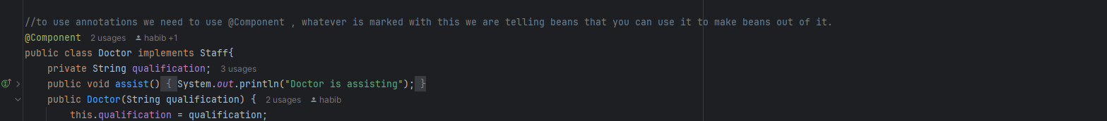

We add this line



In xml to show spring where to find our componenets

.

-> There are many annotations where we have to learn here they are moving to java config.

